
Advance Software Engineering
Stage 1- Group Report

Bhatti, Masroor Ahmad (2013-2014)- H00178736
Naseer, Qasim (2013-2014) - H00159520
Fakhr, Naveed (2013-2014) - H00175609

F21AS: Advance Software Engineering
(Mr. Kohobhange, Ajith P K - Supervisor)

Heriot-Watt University -School of Management and Computer Science (Dubai Campus)

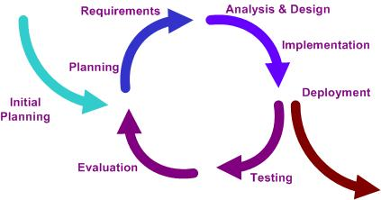
Heriot-Watt University -School of Management and Computer Science (Dubai Campus)

Table of Contents
1- Introduction 3
2- Application Requirements 4
2.1 Application checklist 4
3- UML Class Diagram 6
4- Data Structure 7
4.1 Data structure used 7
4.2 Reasons for selection 7
5- Decisions / assumption during development 8
5.1 - Discount calculation 8
5.2 - Error Handling 8
5.2.1 - Input Error checking 8
5.2.2 - Exception handling 9
5.3 - Unit Testing 11
6- Development Plan 12
6.1 - Development Schedule 12
6.2 – Discussing development plan 12
6.2.1 – development approach impact 13
6.2.2 – Problem faced 13
6.2.3 – deviation from original schedule 13
6.2.4 – Use of iteration 14
7- Users Guide: 15
7.1 Functionality List 16
Following functionalities are provided: 16
Conclusion 17

- Introduction
This project was completed as a group comprising of three members. The amount of work done by the group members was equally distributed after discussions in the group meetings and as submitted in the phase I development plan. The members of the group are stated below.
- Mr Naveed Fakhr H00175609
- Mr Qasim Naseer H00159520
- Mr Masroor Bhatti H00178736

Iterative development was used in order to achieve the best results in developing the project. Version control toolkit (git) was applied to broaden the group working aspect of implementing the application. Each member played his part in the development of the application and achieving the desired results in sufficient amount of time. This application has been designed to be complex enough to enable us to try out various software engineering features whilst small enough to fit in the time available. All the pre-requisites were fulfilled in addition some extra functionality was also added in the application.

- Application Requirements
Developed application meets all required specification of stage 1
2.1 Application checklist
Requirements | Description | Status
Input File | Text files containing details of the orders with table number, Menu and discount offered TableData.csv, Discount.csv and Menu Data.csv | √
Output File | A text file containing details of the menu - dishes, category and prices Output.txt | √
Menu | Displaying the menu | √
Dishes Ordered | A list used to display dishes ordered in the output | √
UnOrdered Dishes | A list of the dishes on the menu that have not been ordered | √
Table details | The cost of all orders for each table | √
Statistics | A few statistics of our own choice | √
Classes (proper use of constructors, proper code comments) | All the classes as required were implemented and were allocated the required functionality | √
Data Structures | Different data structures were applied depending on the requirement of the classes (Tree Map, Tree Set, Hash Map, Array list ,Map, Set) | √
Version Control | Version control took (Git) was utilized in order to achieve version control . | √
Error checking and exception handling in a constructor and error handling by creating a custom class | Error checking was implemented in the classes while data was read from the file and while checking the input custom exception class EmptyValueException & NotFoundException was used to test whether the value of the item is empty. Exception handling in Order constructor was implemented if the table number or quantity or itemname is null in the constructor it throws an IllegalStateException. | √
Input files with and without errors | Input files with and without errors validating all the checks implemented in the application | √
Junit Testing | Junit testing applied to the methods and checked thoroughly. | √
UML (Class Diagram) | Class Diagram of all the classes | √
GUI output | Displaying the bill while entering the table number | √

- UML Class Diagram
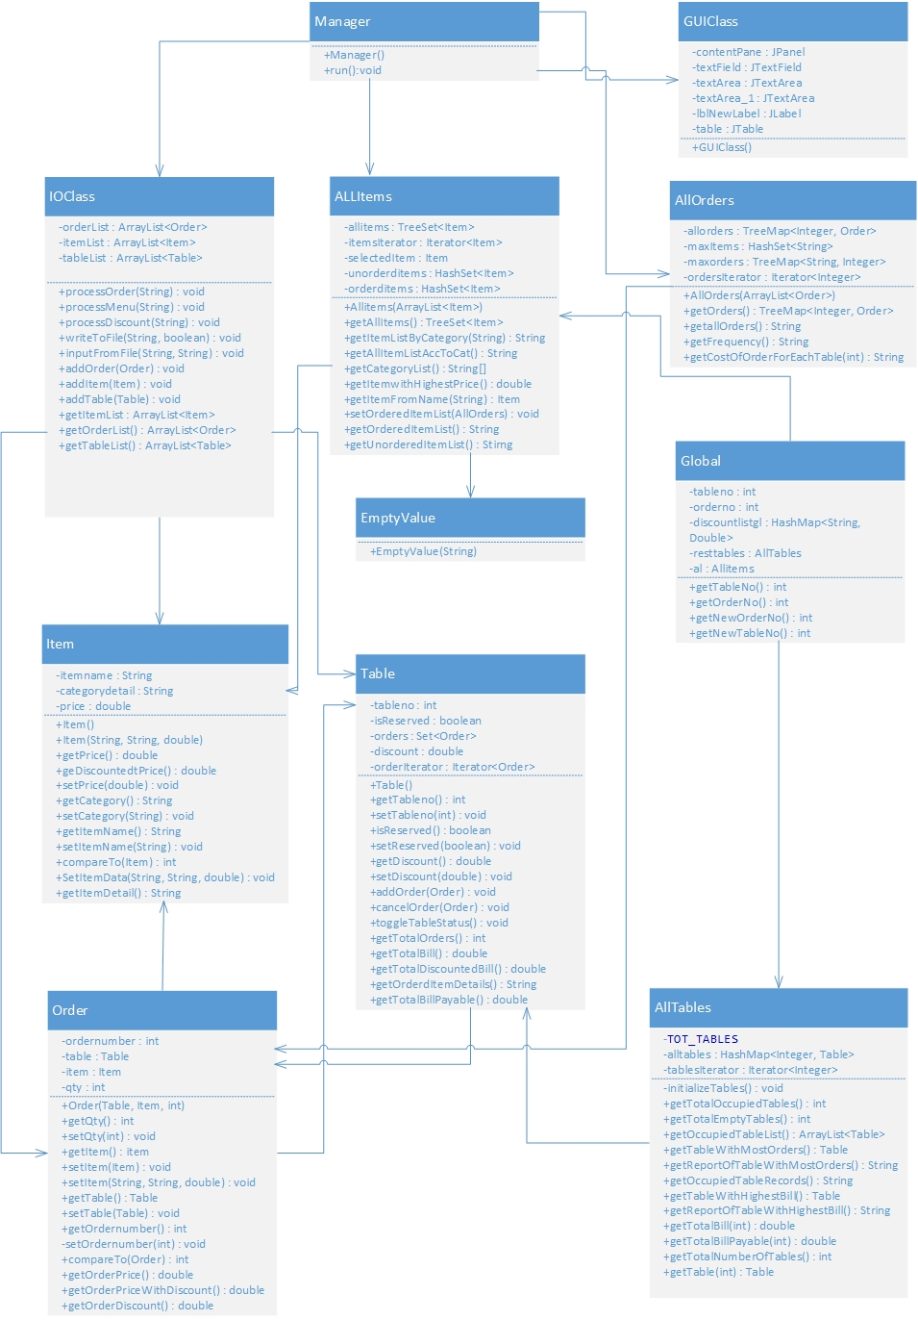

- Data Structure
4.1 Data structure used
A pre-requisite requirement was to use various data structures in different classes. So as per the requirement diverse data structures were used depending on the requirement to fulfill the functionality of the classes. Some of the data structures used are listed below.
4.2 Reasons for selection

Data Structure | Class Name | Reason
TreeSet | AllItems class  Table class | Tree Set was used and it helps in keeping the objects ordered and Set was used so there was no duplication.  In table class, it is helpful to maintain orders for that table without duplicating any order.
TreeMap | AllOrders class | Tree Map was used in order to iterate through the order objects efficiently and finding the order based on key (order no) supported by Map class  Tree also support to order items so it will be helpful when ordering required
HashMap | AllTables class | Hash Map was implemented in this class as no specific order was required and hash and map both help in iterating faster and efficiently through the table object. Moreover it helps to find specified table based on table name as HashMap supports (Key,Value) pair searching and provide fast search because hash.
HashMap | Shared class | Is used to store discount list for category. Based on hash value, it is very fast to find any specific discount %age for passed item name
ArrayList | IOClass class | ArrayLists are used for temporary purpose.e. reading from input files and storing values
HashSet | AllItem class | Used for private data member, to store ordered and unordered items – purpose is to avoid duplicate items to be added into defined sets
- Decisions / assumption during development
5.1 - Discount calculation
Discount is given based on each category rather than items. While generating the bill at first the values are picked from the Menu Data.csv file which contains the original price of the item and than a discount percentage amount mentioned in the discount.csv file for that category from which the item belongs is verified and depending on that the total is calculated.
5.2 - Error Handling
Possible all type of found errors are handled that includes input, processing and output moreover exceptions are also well managed. Following types of exceptions aremanaged:
- EmptyValueException – Custom Exception class
- NotFoundException – Custom Exception class
- IllegalStateException – Used as part of constructor
5.2.1 - Input Error checking
The Tabledata.csv consists of the table number the item name which is ordered and the quantity of that item. A check is applied on this file If the item name entered in this file is not existing in the menu input file that line is skipped and the programs runs rather than coming to complete halt.
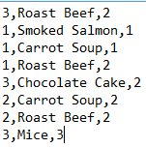
Number format exception is thrown if first value entered in the input file is not an integer.
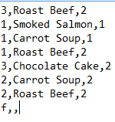
If the values are not fully entered in the list Not enough items error is given.

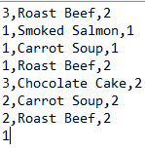
In the Discount.csv if the discount percentage entered is more than 100% is displays and it displays the following error
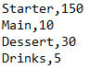
The total number of tables are allocated by default to 10. While displaying the bill of the specified table number which is greater than the allocated value it display a message as shown.
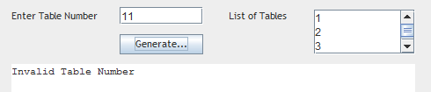
If the table number is between the allocated 10 tables and there are no orders from that table is displays as message as shown.
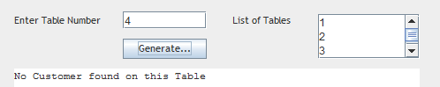
5.2.2 - Exception handling
EmptyValueException (Custom class for Exception handling):
This class is a custom exception handling class which is used in conjunction with the All items class where it checks a specific method used for inserting values in the Menu. While entering the values in the fields if the item name field is left empty. While running the application an error is displayed as show.
NotFoundException (Custom class for Exception handling):
This class is a custom exception handling class which is used in IOClass for handling input from file, if specific input is missing then it throws exception for NotFoundException class

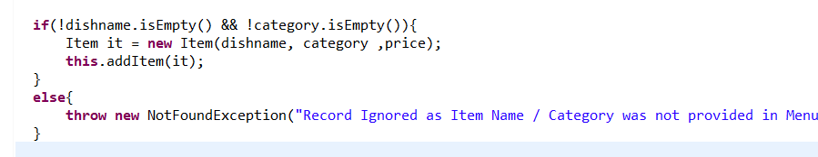
Message displayed
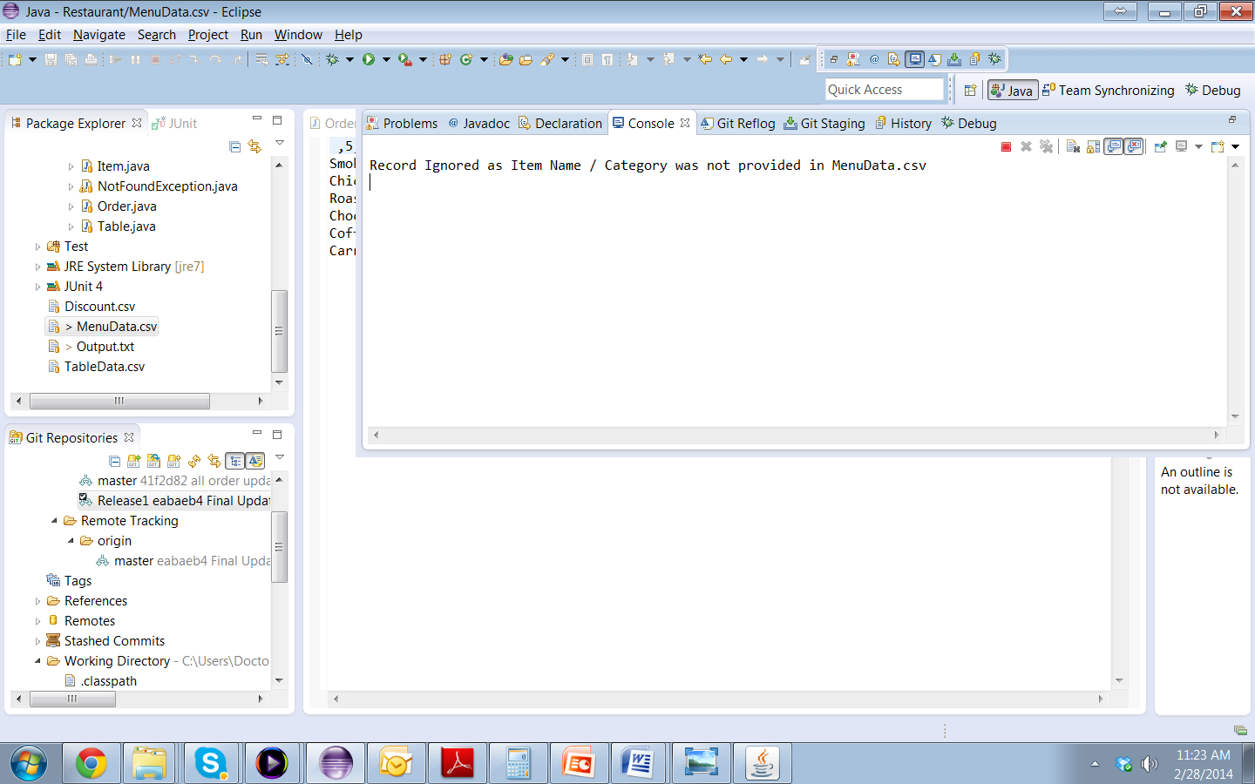
Exception handling in constructor(Order Class):
Exception handling in Order class constructor was applied if the table number, quantity or itemname is null it throws an Illegal Argument Exception and displays the message as shown.
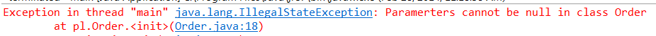.
5.3 - Unit Testing
Two type of unit testing has been applied during current development; JUnit is used for all type of testing. Selection of JUnit was made as is is provided as builtin library in Java and can be directly included eclipse based solution. JUnit also provide facility to fully automate testing procedure and support TDD (Test Driven Development)

Following testes are conducted using JUnit:

- Testing different calculations – Respective Methods’
  - Test order Discount – Order.getOrderDiscount()
  - Testing discount for complete table – Table.getDiscount()
  - Test Order Price calculation – Order.getOrderPrice
  - Test Bill amount for table (with and without discount)
    - Table.getTotalBill()
    - Table.getTotalBillPayable()

- Testing method of Item class
    - Item.CompartTo() method

- Development Plan
6.1 - Development Schedule
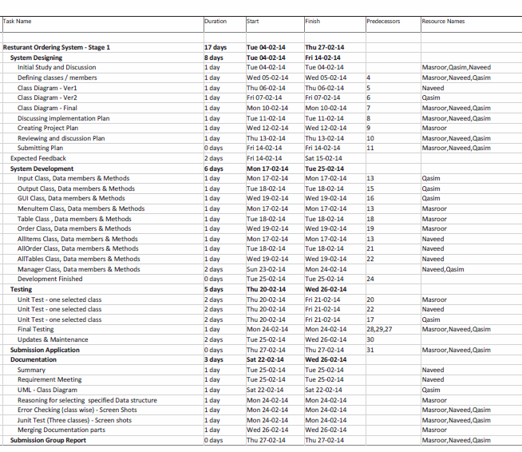
6.2 – Discussing development plan
The development plan put in place at the designing phase of the application was immensely helpful in developing the application.
While developing the application the timeframe mentioned in the development plan was more or less precise and helped in getting the work done in conventional order.
Iterative development was used in order to achieve the best result in the time frame given and each member of the group followed a set of rules as described in the development phase I. Version control tool (git) was implemented in order to expand the idea of group work in developing an application. Some changes were made in the system development phase(e.g. the class data structures as mentioned in the initial class diagram) in order to achieve the desired results.
6.2.1 – development approach impact
The development approach taken had a very positive impact towards the development of the project. Version control tool was very productive as a repository was created on github and each member was registered where all the work done was with mutual consent and each member had interaction with the other two while developing and updating the work done in phases. The benefit of using version control tool was that efficiency was achieved while using it. E.g. if a member was stuck at a task while coding this member could simply commit the code on the repository and the other member could just update his repository and fix the issue without any hustle.
6.2.2 – Problem faced
- A minimal issue while configuring the git repository was confronted by the group members at the starting point in developing the application. That too was resolved without having an impact on the development schedule.
- The other issue faced by the group was in the testing phase of the application where Junit testing took a while to be implemented as no group member had any prior knowledge of Junit Testing.
- One of unexpected problem was maintain same standard and level application to match with OOP structure and principles. This problem appears specially during testing and code review phase and took some extra time as it was not added into initial submitted plan.
6.2.3 – deviation from original schedule
As discussed in the development plan all the work was done in more or less the same time frame as listed in the development schedule. There was a slight deviation at the start of the system development phase where the class structures as defined in the initial class diagram had to be altered in order to achieve the desired results. The other deviation from the original schedule was observed in the testing phase of the application where most of the time was spent on Junit Testing which at the end was achieved through coordination and by mutual consent of the group members.
Lot of cooperation between team was evident, all of team members were online and kept communicating with others using hangouts in last couple of days.
6.2.4 – Use of iteration
Iterative development was used in order to fulfill all the pre-requisites required while developing the application. As listed in the development plan. The project was implemented in 4 phases.
- System Design phase:
The system design put forward in the stage 1, with the initial class diagram had to be altered in order to achieve the desired functionality for the application.
- System Development phase:
The system development phase had all the data structures, data members and classes for the project each of them was allocated equally to all of the group members and the work done was achieved in the desired time period.
- Testing Phase:
Testing phase composed of testing methods imposed on the classes’ as well as Junit testing was also implemented.
- Documentation:
The documentation phase was completed by combining all the work done by the group members while developing the project. Each group member had responsibilities assigned as mentioned in the development plan and accordingly fulfilled the required tasks and at the end all of the work was merged altogether to complete the documentation.
We followed iteration process during whole development that helped to make application functional and responsive. Every group members were required to commit his changes and others put efforts to review, which caused improvement of application by iterating and updating developed parts.
- Users Guide:
The GUI (Graphical user interface) is implemented in this stage as required for only displaying the total bill for all the tables. The user enters the table number from the list of tables displayed on the right hand side of the panel and the total bill of that particular table is displayed in the bottom panel. Exception handling of the GUI part is discussed above in the error handling section.
In case table is occupied
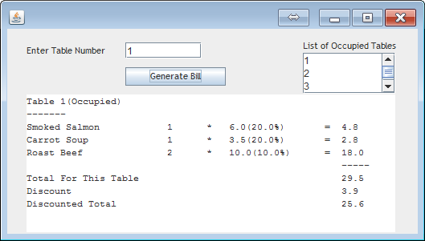
In case of empty table
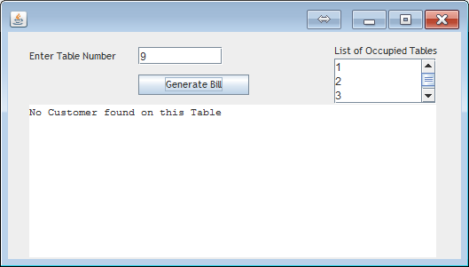
7.1 Functionality List
Following functionalities are provided:
- Input from File
  - Items
  - Orders
  - Discount – Category wise

- Output to screen (GUI)
  - Occupied tables list
  - Bill generation

- Output to file
  - Dishes’ Menu list – Category wise
  - Dishes’ ordered frequency report
  - Dishes not ordered
  - All tables and their bill with discount
  - Detail of table with highest bill
  - Detail of table with most orders

Conclusion
Overall development and focus was learning advance concepts of software engineering as well as its implementation in Java. During the coursework, it was completely new experience for us to use some specialized data structures as we have studied them before but never implemented in a way we did. JUnit was amazing and a fully new concept for us to automate testing process, we tried to explore it but still we think there are more to learn. We are expecting to have more interesting and practical work at stage2.
We also learned how to plan and follow it strictly, as delay in individual task can leads toward stacking of unfinished job; those will be difficult in time.

